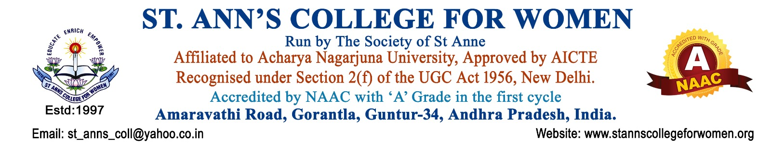

B.Sc Honours – Chemistry
Exploring Innovation Through Chemical Sciences
The B.Sc Honours – Chemistry programme at St. Ann’s College for Women provides strong foundations in organic, inorganic, physical, analytical, and industrial chemistry through practical and research-oriented learning. The programme develops analytical thinking, laboratory skills, scientific knowledge, and problem-solving abilities essential for careers in chemical, pharmaceutical, research, and industrial sectors.
The combination of Chemistry Major with Botany Minor offers interdisciplinary learning in plant sciences, medicinal plants, environmental biology, biotechnology, and natural product chemistry, creating wider opportunities in life sciences and research fields.
Presently offered as a Three-Year Degree Programme.
Programme Highlights
- Strong foundation in organic, inorganic & physical chemistry
- Well-equipped laboratories with modern instruments
- Hands-on training and practical laboratory experience
- Industry-oriented curriculum with scientific applications
- Skill development in chemical analysis and research techniques
- Seminars, workshops, projects, and internships
- Experienced faculty with research-focused teaching
Major Subjects in Chemistry
- Organic Chemistry
- Inorganic Chemistry
- Physical Chemistry
- Analytical Chemistry
- Industrial Chemistry
- Biochemistry
- Environmental Chemistry
- Pharmaceutical Chemistry
- Instrumental Methods of Analysis
Minor Course – Botany
The Botany Minor strengthens understanding of:
- Plant Diversity & Taxonomy
- Plant Physiology
- Medicinal Plants
- Ecology & Environmental Science
- Plant Biotechnology
- Biodiversity Conservation
Career Opportunities
Graduates can pursue careers as:
- Chemist
- Analytical Chemist
- Lab Technician
- Quality Control Analyst
- Research Associate
- Biomedical Chemist
- Forensic Chemist
- Pharmaceutical Industry Professional
- Research & Development Executive
Employment opportunities are available in:
- Pharmaceutical Industries
- Chemical Industries
- Biotechnology Companies
- Research Laboratories
- Food & Environmental Industries
- Educational & Research Institutions
Students may also pursue higher education such as M.Sc Chemistry, Applied Chemistry, Biochemistry, Analytical Chemistry, Pharmaceutical Chemistry, Biotechnology, and related science programmes.
Eligibility Criteria
- Intermediate / Class XII with MPC / BiPC or equivalent
- Recognized Board of Education
Why Choose St. Ann’s College for Women?
- Well-equipped science laboratories
- Research-oriented learning environment
- Practical exposure and industry-focused training
- Student-centered academic approach
- Encouragement for innovation and scientific exploration
- Strong support for higher education and career growth
Contact Us
St. Ann’s College for Women
Amaravathi Road, Gorantla, Guntur – 522 034
📞 0863-2236470
📱 73821 04655, 85006 56134
🌐 www.stannscollegeforwomen.org
Admissions Open 2026–27

